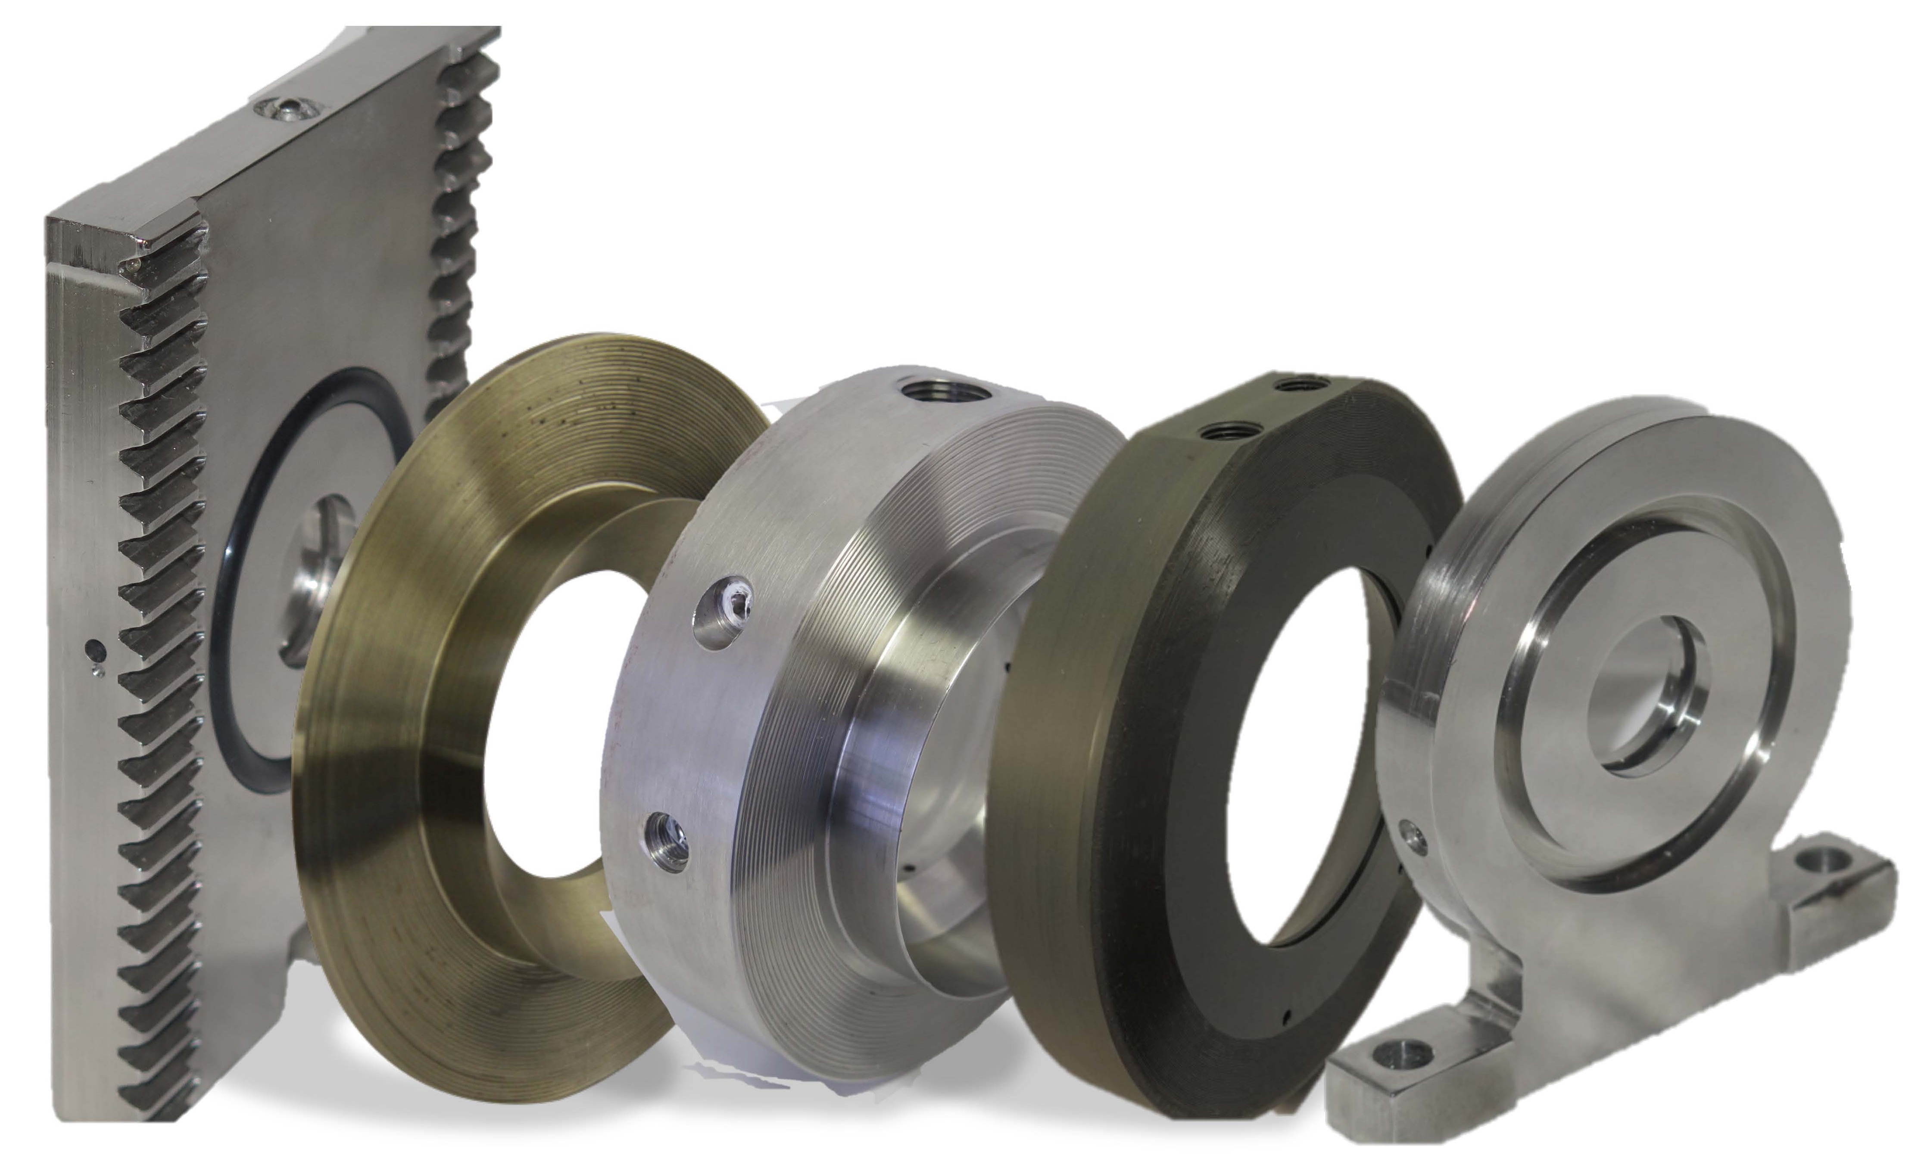

**INDUSTRIES**

* Water
* Utilities
* Oil & Gas
* Chemical
* Refining

**APPLICATIONS**

* Water Management
* Drilling/ Production
* Multiphase, Slurries
* Gas / Wet Gas
* Desalination
* Produced/Tieback Water
* Plants
* Sanitary Service
* Steam
* Chemical Injection
* Fuel Measurement

**SIZES**

Up to 24” (larger, consult factory)

**PRESSURE**

: Vacuum to 20,000 psig

**The TORUS CENTER-TAP Flow Measurement Device**

* New application for Differential Pressure
* Custody transfer qualified by API 22.2
* Simple installation, between flanges
* Elimination of weaknesses of Orifice Plate and seal rings
* Stand-alone meter for all directional and bi-directional flows
* No profiler or straighten vanes required -- 5D up and 3D down
* **Available in RETROFITABLE SOLID CARRIER** for **oil and gas applications – OFU single and dual chamber fittings**
* Unlimited size, pressure and process usage
* Unlimited material selection
* Utilized in all measurement Industries
* More accuracy for less cost
* **SAFETY DEVICE for some industries: i.e., drilling fluids**
* Low cost of operation and maintenance
* Provides self-diagnostics by adding one transmitter

For more information of this or other versions of the TORUS, contact **Dave Bell, CTO, at 832-746-7179 (mobile) or**  by emailing dbell@belltrchnologiesllc.com.

-

**Applications**

**1167 Barkston, Katy, Houston, TX 77450**

**Phone: 713-465-7575**

**www.belltechnologiesllc.com**

**btllcsales@belltechnologiesllc.com**